Eyeconic-Sprays Shop Management System

Use-Case Specification: Remove Sprays

Version <1.0>

Revision History

|  |  |  |  |
| --- | --- | --- | --- |
| **Date** | **Version** | **Description** | **Author** |
| <04/11/2019> | <1.0> | creating use case | Nguyễn Tuấn Anh |
|  |  |  |  |

Table of Contents

1. Remove Sprays 4

1.1 Brief Description 4

2. Flow of Events 4

2.1 Basic Flow 4

2.2 Exception 4

2.2.1 Remove Sprays 4

2.2.2 Confirming editing the brand 5

3. Special Requirements 5

4. Preconditions 5

4.1 Admin must be logged in 5

5. Postconditions 5

6. Extension Points 5

Remove Sprays

# Remove Sprays

## Brief Description

This use case defines the step of delete exist Sprays from the database.

Sprays are removed by the admin.

# 2. Flow of Events

## 2.1 Basic Flow

The system administration selects the Sprays data to remove. The administrator deletes the Sprays data from the website. The system displays the updated management parameter value and logs the change

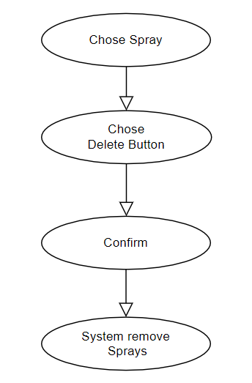

***Basic flow of Removing Sprays***

Step 1: Choose the Sprays you want to remove

Step 2: Click remove button

A modal view shows up with content “Are you sure want to remove this item?”

and two button “Yes” and “No”

Step 3: Confirming adding the Sprays by clicking the “Yes” button.

Step 4: Sprays are removed from database and no longer appeared on the screen.

## 2.2 Exception

### 2.2.1 Remove Sprays

The remove button cannot be clicked or isn’t appeared on the screen

### 2.2.2 Confirming editing the brand

The “Yes” button is clicked but the brand are not removed

# 3. Special Requirements

No Special Requirements

# 4. Preconditions

## 4.1 Admin must be logged in

User must already login as the administrator of the website

# 5. Postconditions

All others product can be shown and purchases as normal.

Deleted Sprays cannot be seen on the screen or database.

# 6. Extension Points

Administrator check the website and the system to ensure that the Sprays is completely removed.